**Assignment 2**

**Minsoo Park**

***5.2 Consider the problem of solving two 8-puzzles.***

1. Initial state: two sets of 1,2,3,4,5,6,7,8 tiles are existed with one empty space on 3x3

Successor function: move to up, down, left, and right

Cost: 1 per move

Goal test: 2 puzzles are reached to organized goal state.

1. 9! Is the total possible number of reachable, but if we want to solve puzzle it is being half.

Therefore, expression is (${\frac{9!}{2})}^{2}$

1. We can use, minmax or expectimax search, especially depth-limited is good for this situation
2. If we assumed both play perfectly, they have same complete number to reach goal state, so both or early start player will win.

***5.6 Discuss how well the standard approach to game playing would apply to games such as tennis, pool, and croquet, which take place in a continuous physical state space.***

Those three games are occurred in continuous space. For the tennis goal state is bit acceptable than other two sports. It means, tennis can be applied easier strategy it. There can be random event or chance, but pool and croquet should be focused on specific goal state.

***5.8 Consider the two-player game described in Figure 5.1.7.***

1. 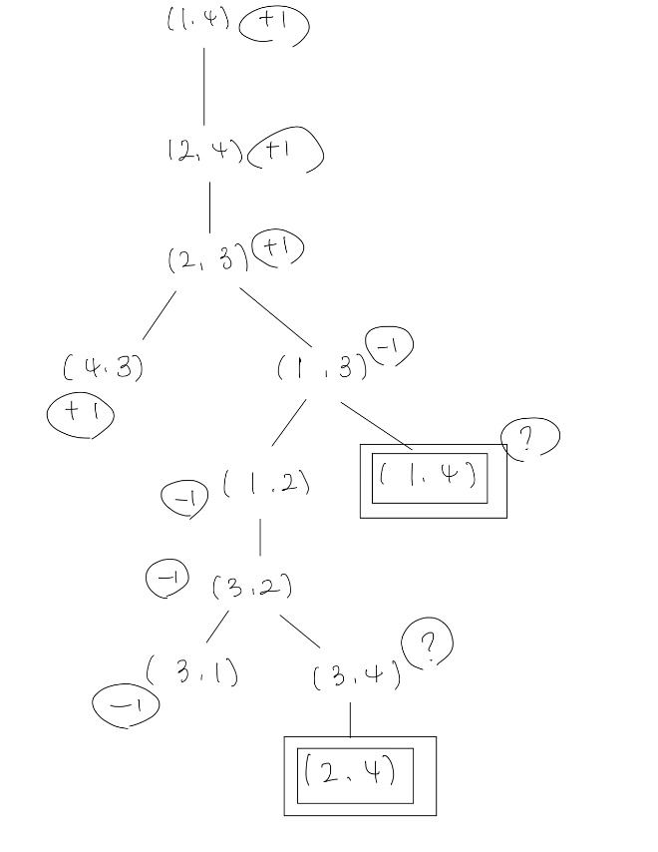
2. The ‘?’ states are already appear on the previous node, and they can’t show exact one player is won. It means min value (-1, ?) is -1 and max value (+1,?) is 1, in the other word draw state.
3. The standard minmax algorithm is using DFS, when it goes to infinite loop, it can be messed up. So we can set up infinite loop as draw value (0) to avoid having same statement with different game value.

***5.16 This question considers pruning in games with chance nodes. Figure 5.19 shows the***

***complete game tree for a trivial game. Assume that the leaf nodes are to be evaluated in left to-***

***right order, and that before a leaf node is evaluated, we know nothing about its value—the***

***range of possible values is −∞ to ∞.***

1. 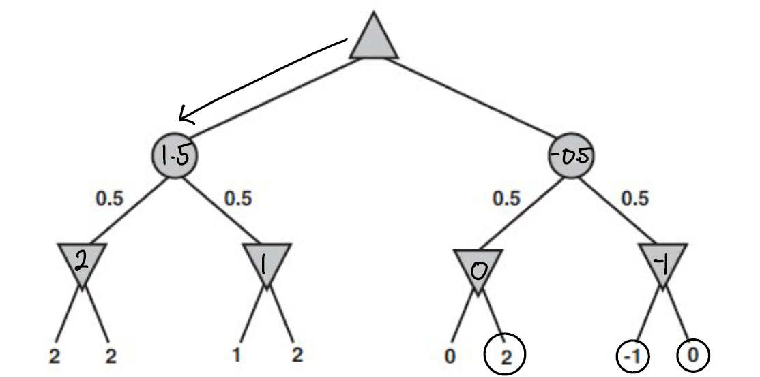
2. Yes, we only know the value is −∞ to ∞. So when we evaluate one to sixth leaves, we have best min value 2 from first two leaves. However there are still chance to get better min value from seventh and eight leaves.

But if we get seventh value, we don’t need to evaluate eight leaf because -1 is already lower min value than our best min value, so we can prune other leaf.

1. For the range -2 to 2, the worst case of left chance node is 0 and best case is 2. Therefore, range is 0 to 2.
2. Include on part A.

***5.18 Prove that with a positive linear transformation of leaf values (i.e., transforming a***

***value x to ax + b where a > 0), the choice of move remains unchanged in a game tree, even***

***when there are chance nodes.***

When we use expectimax, we calculate the average of sum of leaves which means if a is always positive value the choice of order doesn’t change.

Because the all of leaves are multiplied by positive value a and same b, it means all values increased same ratio.

For example if two leaves 2,4 and other two leaves -1, 5 we get (2 + 4)/2 = 3 and (-1+5)/2 = 2, so our choice is left chance node. However if we apply new function with 2x+1, we have new two leaves 5,9 and -1,11. And then average value are 7 and 5. Therefore our choice is still left chance node.

***5.20 In the following, a “max” tree consists only of max nodes, whereas an “expectimax”***

***tree consists of a max node at the root with alternating layers of chance and max nodes. At***

***chance nodes, all outcome probabilities are nonzero. The goal is to find the value of the root***

***with a bounded-depth search. For each of (a)–(f), either give an example or explain why this***

***is impossible.***

1. No, it can’t be pruning. If there are only max nodes, we are looking for max value on every leaves. It means, there are always chance to next leaf values or next nodes’ leaves have higher than previous.
2. No, we can’t. It is similar as part a). There are always probability to get higher value from next leaves and anyway if there are no range for leaf values, we should know every leaf values to calculate the chance nodes.
3. No, we it’s impossible. Just same as part a), this condition doesn’t counter prove the a) statement. There can be possibility of higher value than previous.
4. No, we talked on part b). If value is nonnegative the new value can lead higher number than previous chance nodes.
5. Yes, if first or previous leaf value was 1, we don’t need to check other leaves, because 1 is highest value in range.
6. Yes, assuming left to right order, we can prune it. if first chance node has two leaves 1 and 1 the chance node value is 1, and then if next chance node’s first leaf is lower than 1, the next leaf can be pruned, because there is no number to get higher average on certain range.
7. (ii) Highest probability first. Because higher probability has more chance to get higher chance node value

13.8 Given the full joint distribution shown in Figure 13.3, calculate the following:

1. P (toothache)

= 0.108 + 0.012 + 0.016 + 0.064 = 0.2

We also have (not toothache)

= 0.072 + 0.008 + 0.144 + 0.576 = 0.8

(0.2,0.8)

1. P (Cavity)

= 0.108 + 0.012 + 0.072 + 0.008 = 0.2

(Not cavity)

= 0.016 + 0.064 + 0.144 +0.579 = 0.8

(0.2,0.8)

1. P (Toothache | cavity)

= (0.108+0.012) / 0.2 = 0.6

(Not toothache)

= (0.072 +0.008) / 0.2 = 0.4

(0.6,0.4)

1. P(Cavity | toothache ∨ catch)

(toothache ∨ catch)

= (0.108 + 0.012 + 0.016 + 0.064) + (0.072 + 0.144) = 0.416

(Cavity | toothache ∨ catch)

= (0.108 + 0.012 + 0.072) / 0.416 = 0.462

(Not cavity | toothache ∨ catch)

= (0.016 + 0.064 + 0.144) / 0.416 = 0.538

(0.462,0.538)

***13.13 Consider two medical tests, A and B, for a virus. Test A is 95% effective at recognizing***

***the virus when it is present, but has a 10% false positive rate (indicating that the virus***

***is present, when it is not). Test B is 90% effective at recognizing the virus, but has a 5% false***

***positive rate. The two tests use independent methods of identifying the virus. The virus is***

***carried by 1% of all people. Say that a person is tested for the virus using only one of the tests,***

***and that test comes back positive for carrying the virus. Which test returning positive is more***

***indicative of someone really carrying the virus? Justify your answer mathematically.***

P(A | V) = 0.95

P(A | ¬V) = 0.1

P(B | V) = 0.9

P(B | ¬V) = 0.05

P(V) = 0.01

P(¬V) = 0.99

We need to compare P(A | V) and P(B | V) when P(V) and decide it which is more indicative.

There are two options, when a person has virus and test return positive result other is when a person doesn’t have virus but test return positive.

P(V)⋅P(A | V) / P(V)⋅P(A | V) + P(¬V)⋅P(A | ¬ V)

= (0.01) * (0.95) / ((0.01) * (0.95) + (0.99) + (0.1))

= 0.0095 / 0.1085 = 0.088

P(V)⋅P(B | V) / P(V)⋅P(B | V) + P(¬V)⋅P(B | ¬ V)

= (0.01) * (0.9) / ((0.01) * (0.9) + (0.99) + (0.05)

= 0.009 / 0.0585 = 0.1538

Therefore, Test B has more indicative to return positive result.